Name: __________________________________
Please circle one division: Basketball or Cheer
Age: _____ DOB: ______________ Sex: ________
School: _________________ Grade: ________
Parent/Guardian Name: _______________________________________
Address: ________________________________
City: ___________________________________
State: _______________ Zip: ________________
Phone: ________________________________
Email: ________________________________
Please Circle One Shirt Size:
Youth: S M L Adult: S M L XL
CHEERLEADERS - CIRCLE ONE SKIRT SIZE ALSO:
YOUTH: XS S M L ADULT: S M L XL

Preschool-6th Grade Basketball
& K-2nd + 3rd-6th Grade Cheer
REGISTER BY: December 5th & Save $10!

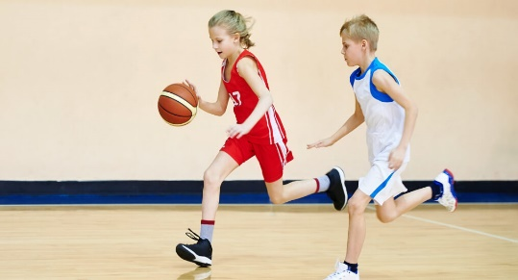


REGISTRATION ENDS AT 4PM ON DECEMBER 12, 2025
Practices begin after Winter break.
Games will be held on Saturdays. Space is limited!
To ensure enrollment please include player fee with registration before the deadline. After deadline, call for availability.
PLEASE INCLUDE YOUR DRIVERS LICENSE NUMBER ON CHECKS
(Returned Check Fee: $20)
*No Refunds after First Practice - All refunds are subject to a $2 fee*
*There will be NO SWIITCHING TEAMS after teams have been assigned!*

PLEASE HELP IF YOU CAN!

Coach: _____ Assist. Coach: _____
Sponsor Team (fee $200.00) ______
*To ensure player safety a background check will be done on all BCPR staff & volunteers

LIABILITY RELEASE: By signing below I, as a participant or legal guardian representing a minor participant, agree to release the Brown County Parks & Rec. (“BCPR”) Dept, its officers, sponsors, employees, and volunteers from all liability for accidents, injuries, illnesses (including but not limited to unknown risks/exposure to COVID-19) loss of and/or damage to my/our person or property that may arise out of my/our participation in or my/our presence at the above activity(s). I/We are aware that there are certain risks or possible dangers in participating in this activity. I have entered into this agreement of my own free will.
MEDICAL RELEASE: In case of illness or accident, permission is granted to take the above person to the hospital or doctor’s office for medical attention.
Code of Ethics Release: As a participant or spectator, I (we) agree to abide by, follow and comply with the rules, policies, and expectations of the BCPR programs and will conduct myself (ourselves) in a courteous and respectful manner by exhibiting good sportsmanship and being a positive role model for youth. I (we) also understand that failing to do so will constitute grounds for sanctions and/or dismissal of participant from the program.
Picture Release: I, as a participant or legal guardian representing a minor participant agree to allow BCPR to use pictures taken at events for promotional purposes.
Emergency Contact (if parent/guardian cannot be reached): __________________________
Emergency Contact Phone: ___________________________________________________
Physical Limitations (allergies, hearing, sight, etc.):
__________________________________________________________________________
Parent/Guardian Signature: _____________________________________________

Player Fees:
EARLY BIRD SPECIAL! REGISTER BY DECEMBER 5TH TO SAVE $10!
Pre-K $55 (EB $45.00)
1st-2nd $55 (EB $45.00)
3rd-4th $60 (EB $50.00)
5th-6th $60 (EB $50.00)
Cheer K-2 & 3-6 $60 (EB $50.00)
($10 discount for each additional child)

Please read, complete, and return with payment to:
Brown County Parks & Recreation
902 Deer Run Lane Ste B
Nashville, IN 47448
Phone: 812-988-5522
Or register on-line @ bcparksrec.com

